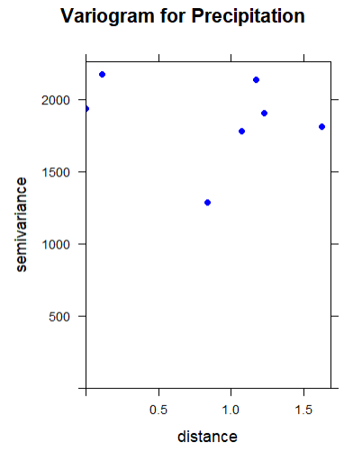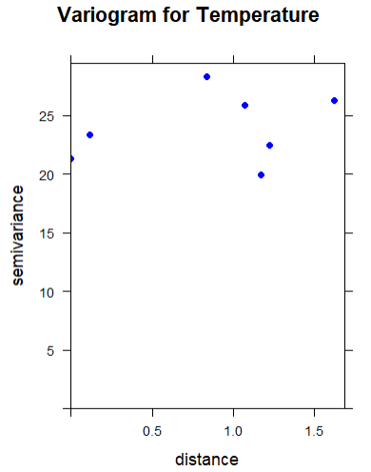

Both precipitation and temperature models reveal significant temporal and spatial dependencies, but not a spatio-temporal interaction. For precipitation, the model shows a highly significant non-linear trend over time (p=0.00102) and a strong spatial dependency (p<2e−16), as supported by the variogram. However, the interaction term between space and time is not significant (p=0.68004), suggesting the spatial pattern of precipitation doesn't change over time. The model's low deviance explained (5.89%) indicates that a significant amount of precipitation variability remains unexplained.

The temperature model also exhibits a highly significant spatial pattern (p<2e−16) and a significant temporal trend (p=0.00395). Similar to the precipitation model, there is no significant spatio-temporal interaction (p=0.19648), meaning the spatial distribution of temperature remains relatively constant over time. The variogram for temperature reinforces this strong spatial autocorrelation. While the temperature model has slightly more explanatory power (7.94% of deviance explained), both models suggest that other factors not included in the analysis are needed to fully account for the observed variability.

Temperature is a spatially continuous and predictable variable, as evidenced by its variogram showing a clear spatial correlation and a defined range. In contrast, precipitation is a highly discontinuous and less predictable variable, showing significant variability even at short distances and lacking a clear spatial structure. This makes it far more challenging to model and predict precipitation with the same level of accuracy as temperature.